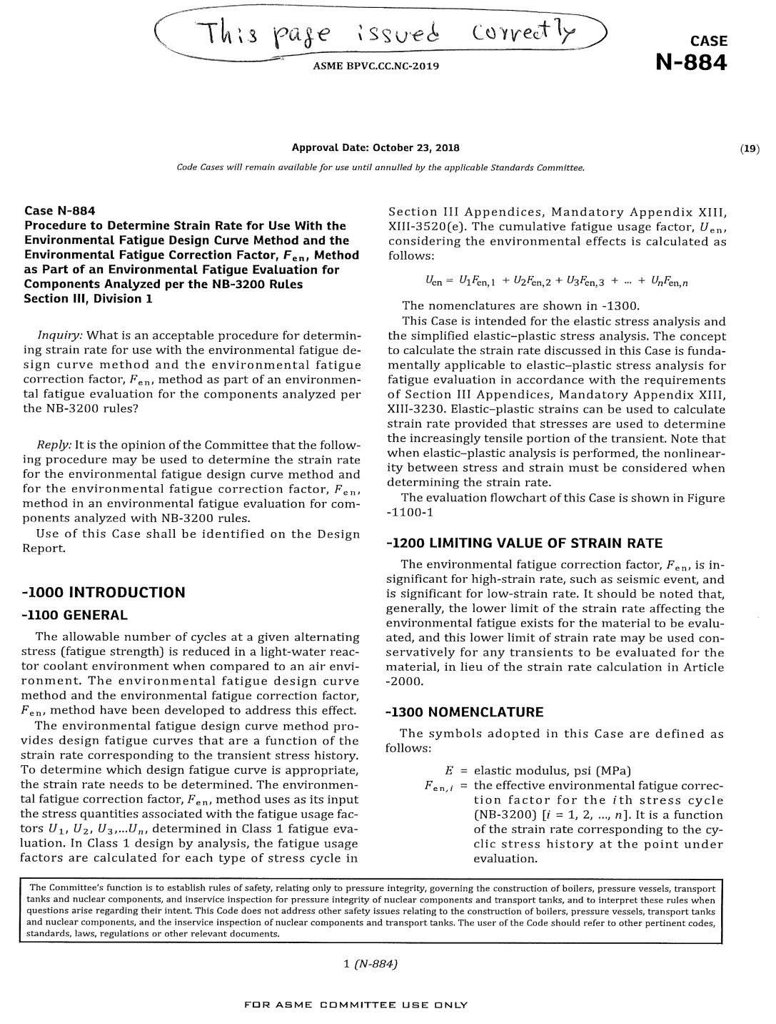

FOR INFORMATION ONLY

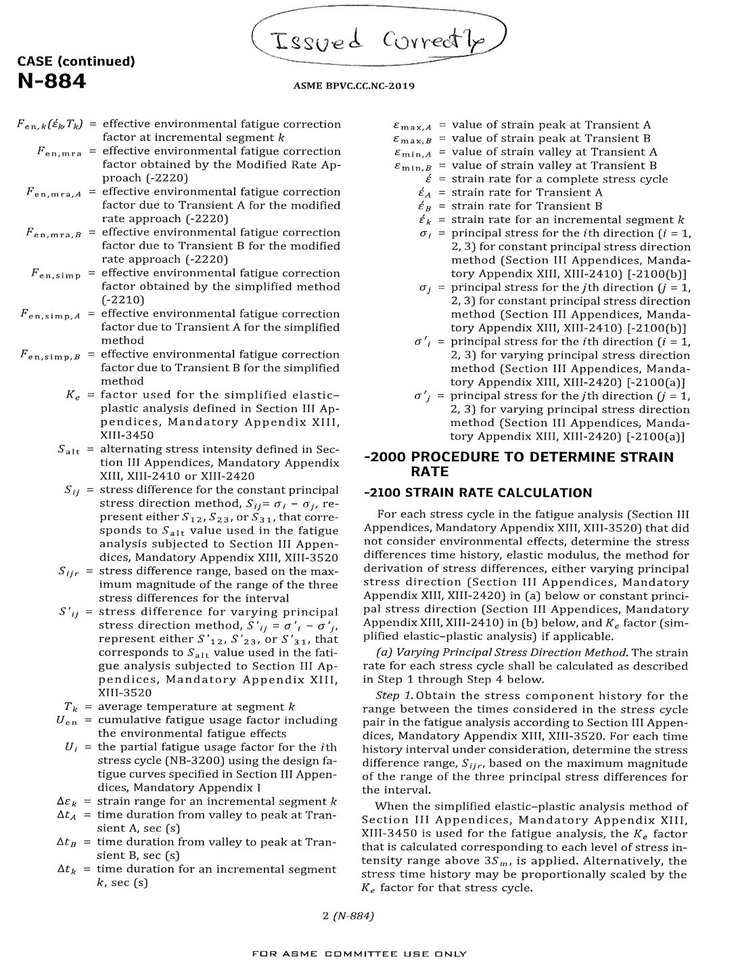

FOR INFORMATION ONLY

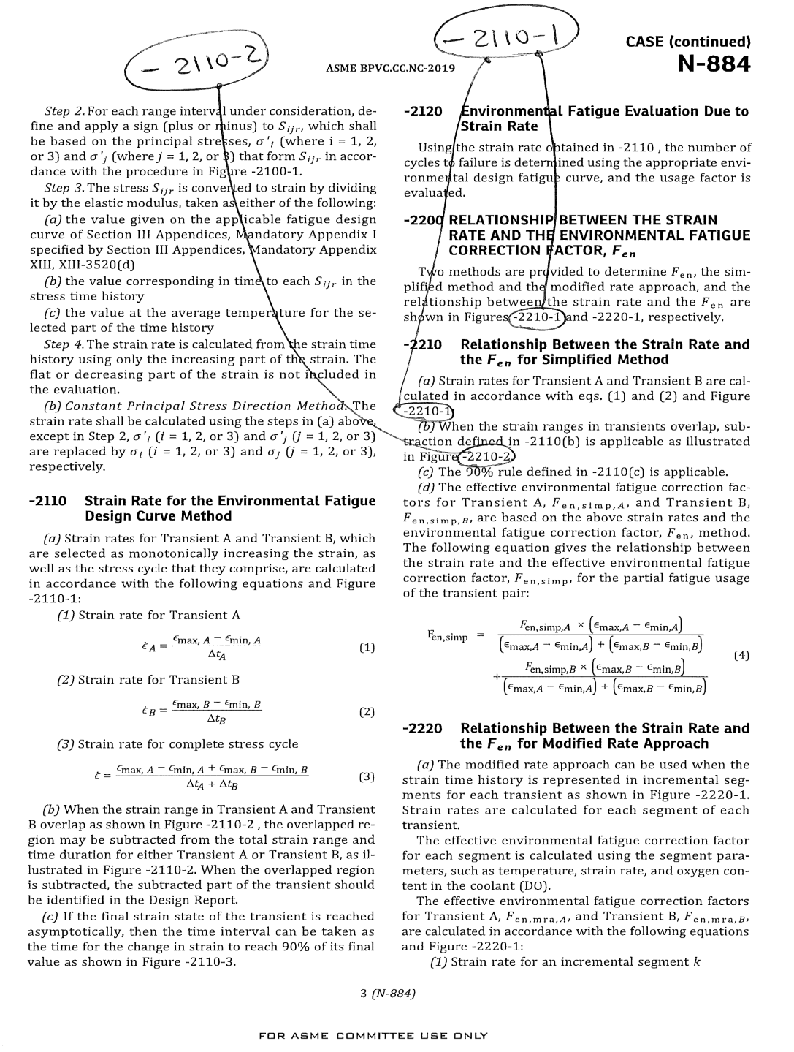

-2110-1

-2110-2

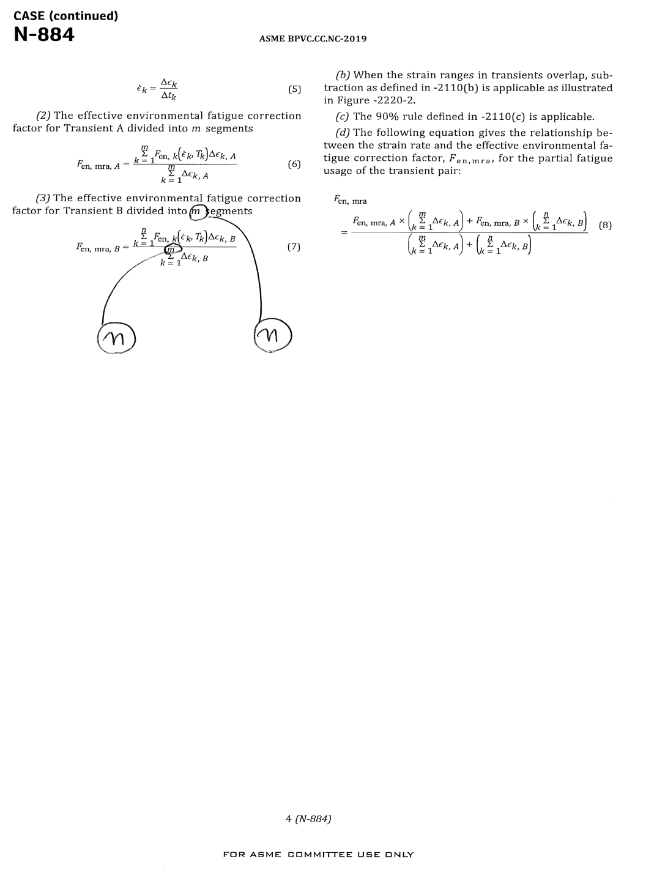

*n*

*n*

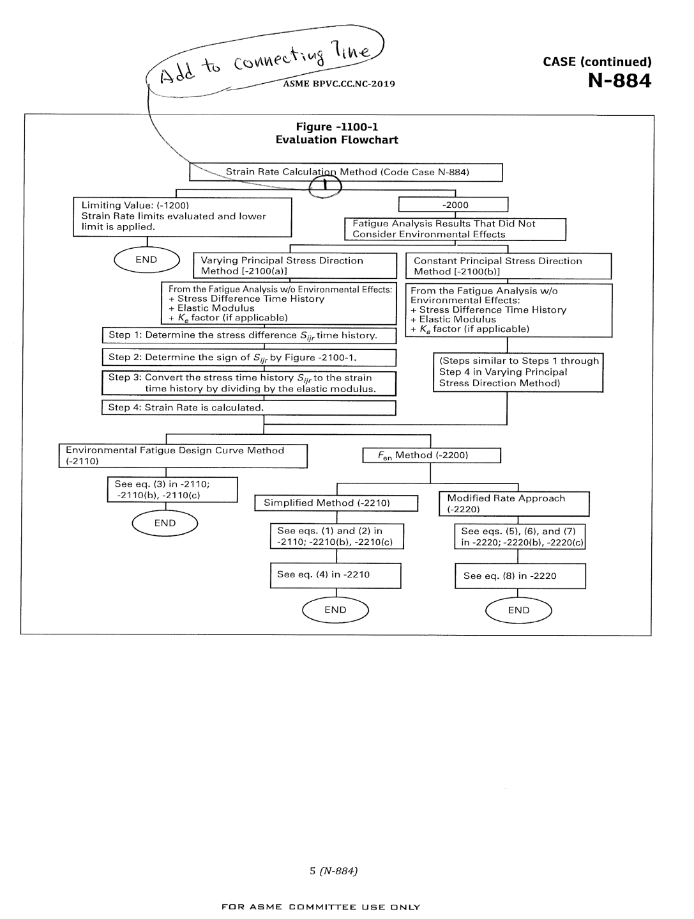

(Note to editors: add connecting line shown.)

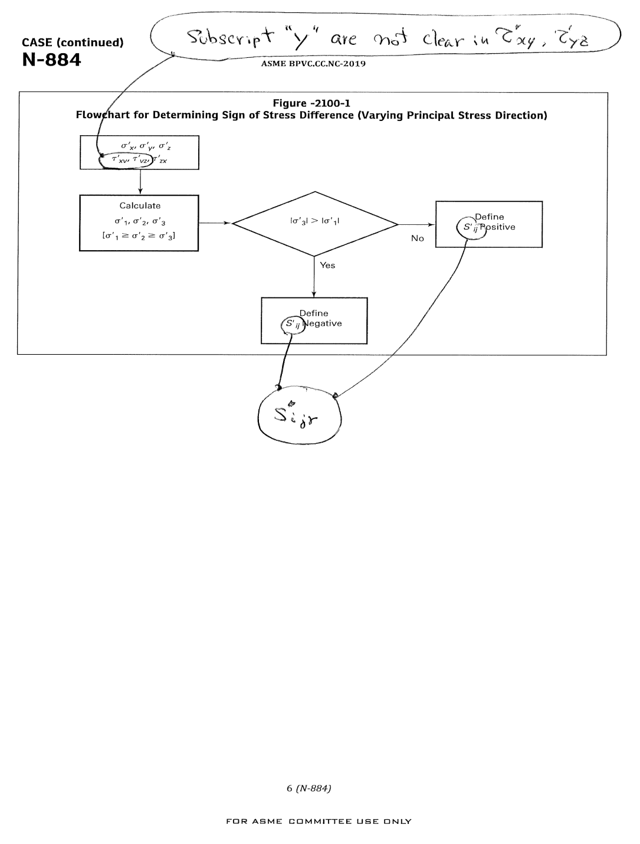

*τ'xy, τ'yz* (Note to editors: descending tail of “y” must be visible.)

*Sijr*

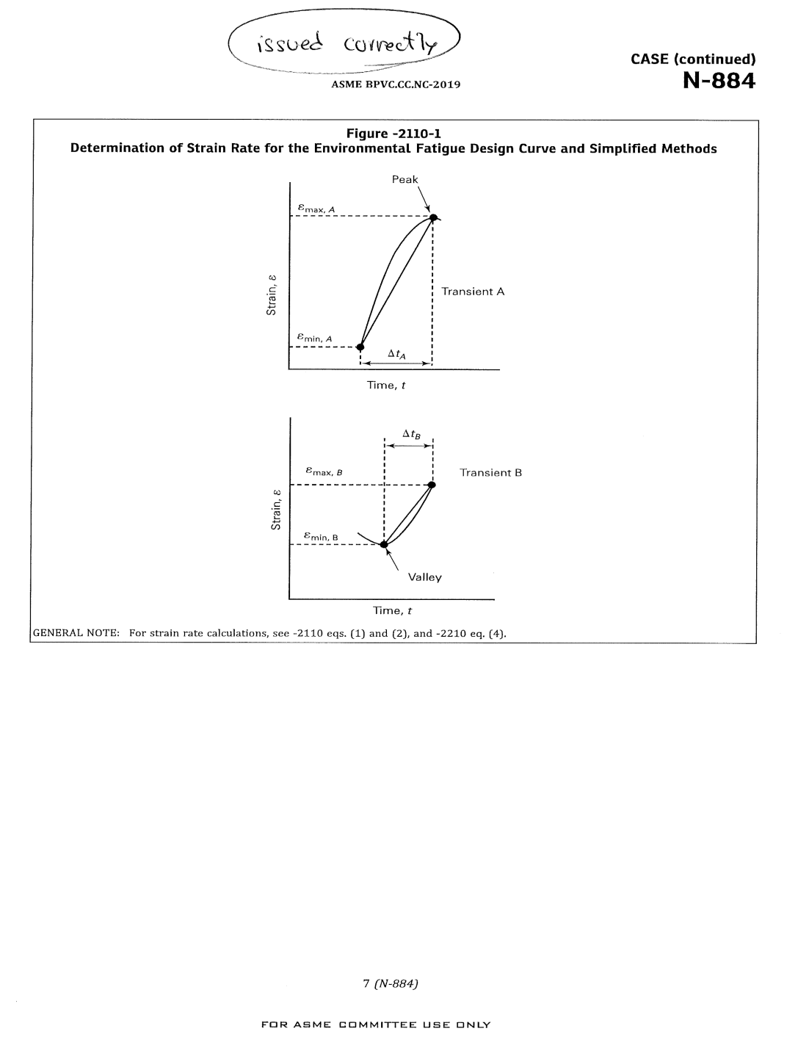

FOR INFORMATION ONLY

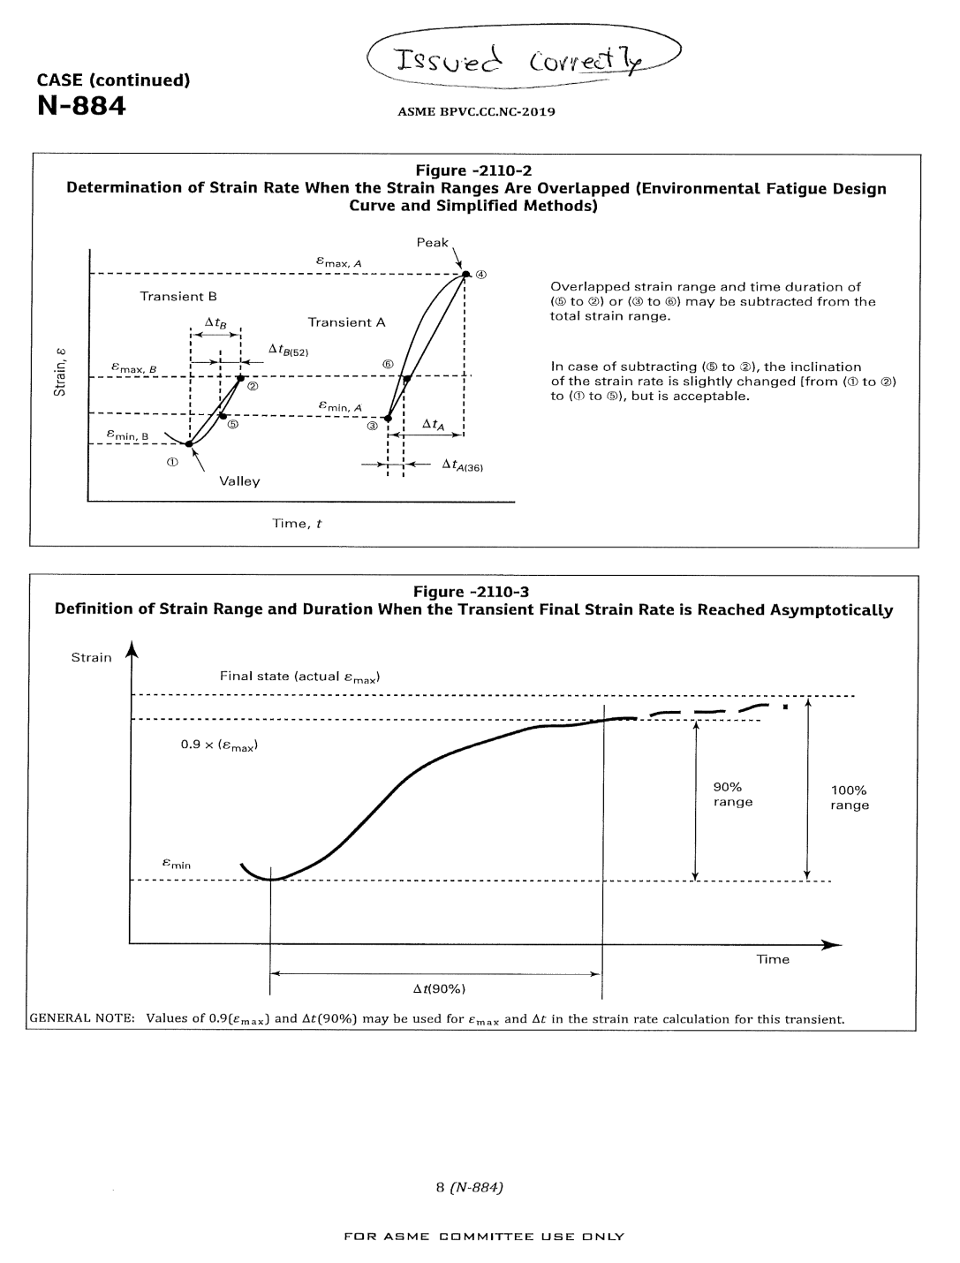

FOR INFORMATION ONLY

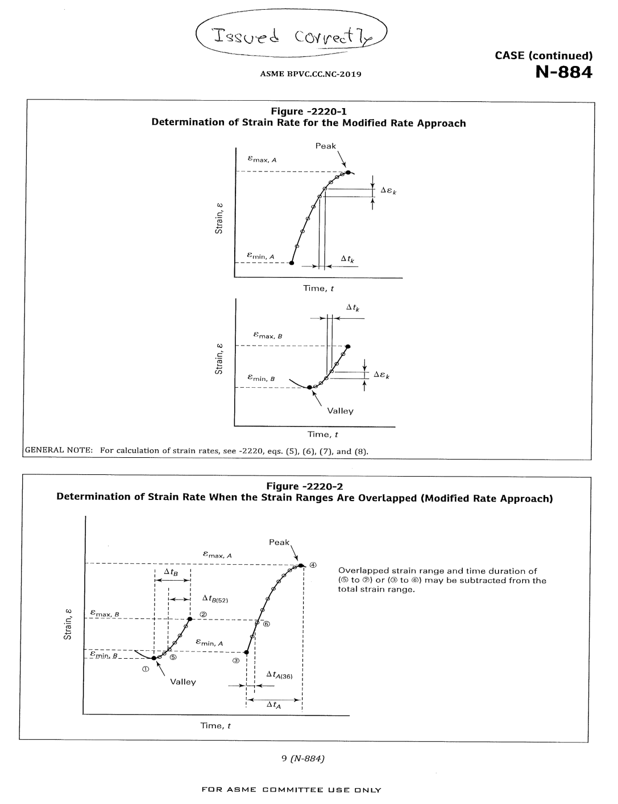

FOR INFORMATION ONLY