**NC-3650 Changes**

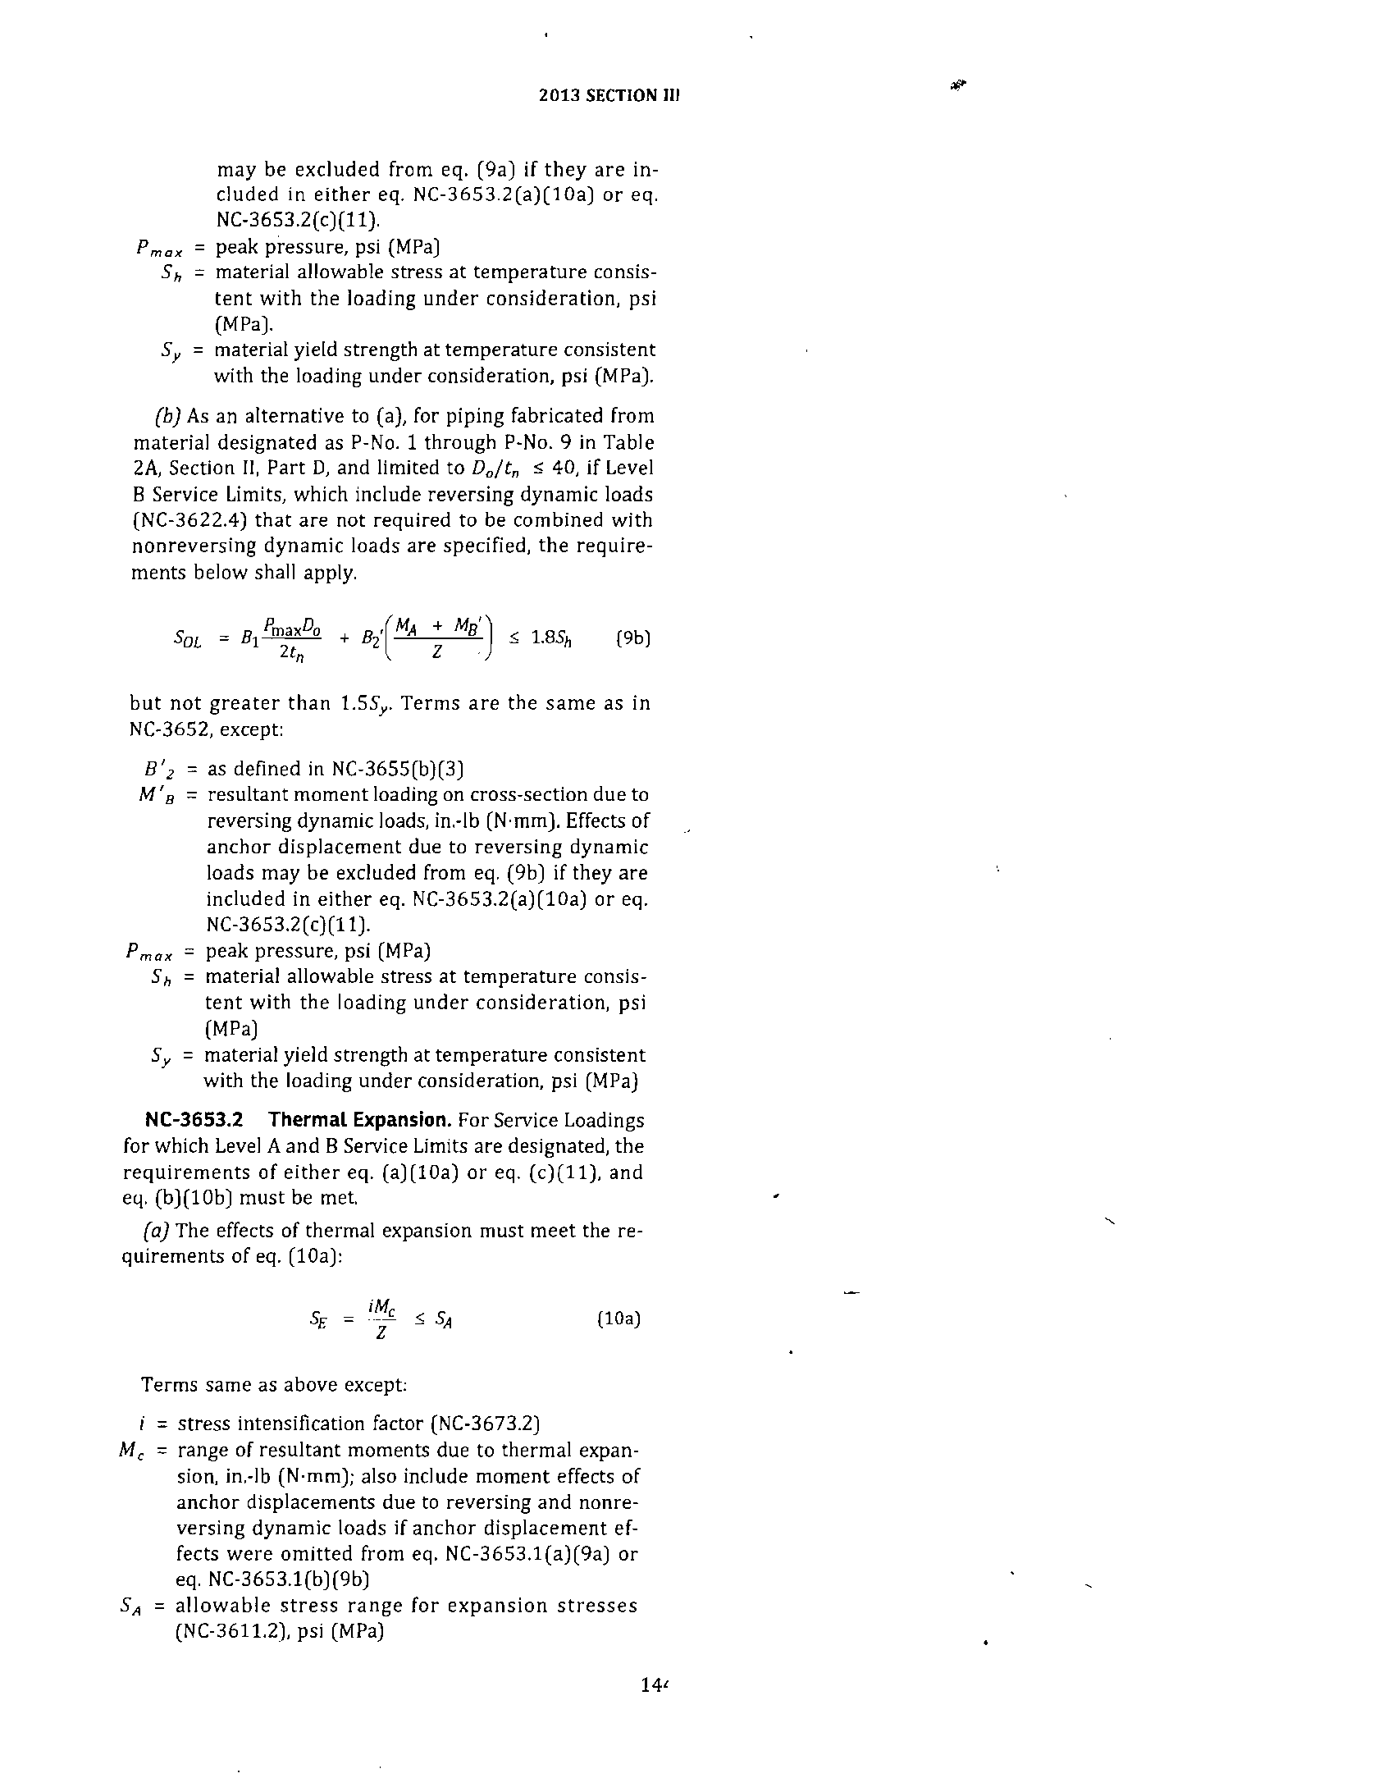

144

a

a

a

a

**ND-3650 Changes**

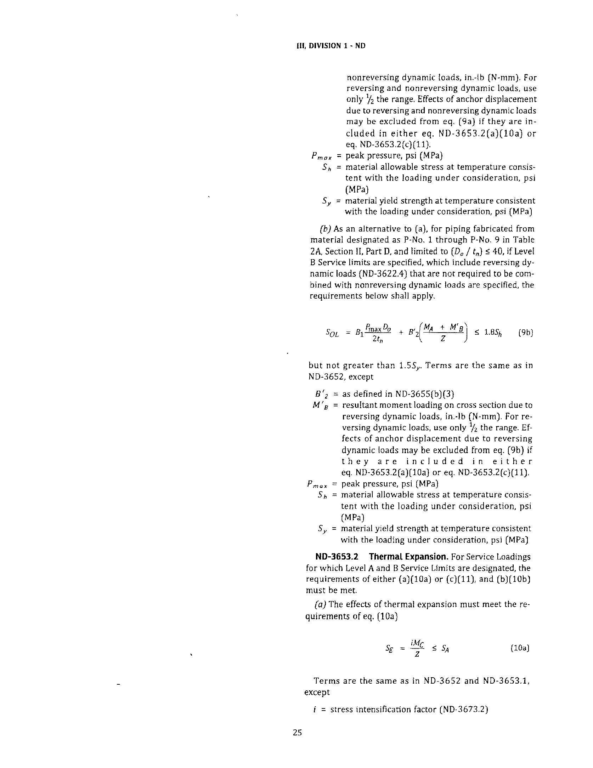

125

a

a

a

a