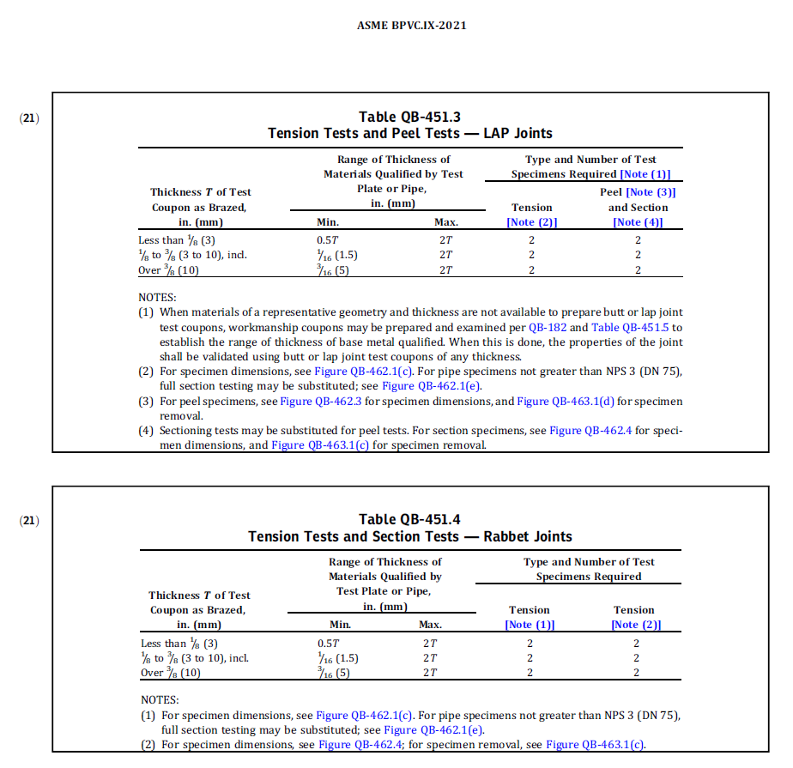
Section

For info, summary of changes: Tension should be Section above Note (2) in Table QB-451.4.

THIS PAGE FOR INFORMATION ONLY – indicates that referenced figures in Note 2 contain information about Section specimens.
