Record 20-2043_Rev. 1
Brian D. Laite
May 04, 2022
Current Wording of Art. 1, I-121.4 MT – Magnetic Particle | Proposed Changes in red
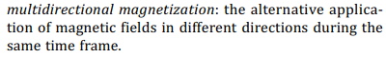 | Multidirectional magnetization: two or more magnetic fields in different directions imposed on a part sequentially and in rapid succession, as one examination, utilizing specialized equipment.

