Record 17-2795 Con Wilson, Project Manager December 16, 2017

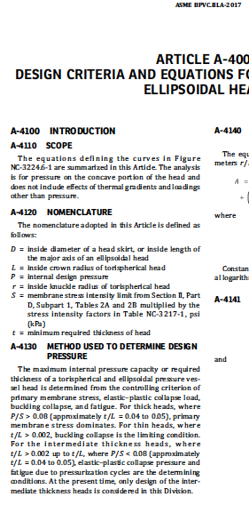
“For the intermediate thickness heads, 0.05 > t/L > 0.002, where P/S < 0.08, elastic-plastic…”

The purpose of this change is to clarify the sentence.

