Record 17-1999 Con Wilson, Project Manager December 16, 2017

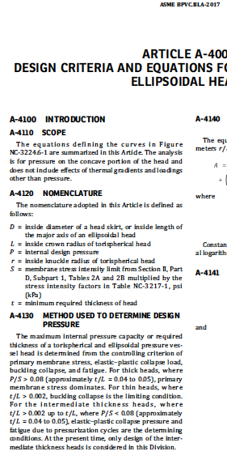
t/L < 0.002

