Subject: Mandatory Appendix II Amplitude Control Linearity
Edition/ Addenda: ASME BPV V 2015 and Later
Paragraph/ Fig. / Table No.: Article 4 Mandatory Appendix II (II-440)
Action: To fix Table II-440 (2015 and later editions of the Code) the RED column in the upper table needs to be replaced with the BLUE column of the lower table.
2015 and later table (incorrect)
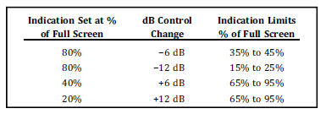
Prior to 2015 table (corrected)
 | Indication Set at %  Of Full Screen | dB Control  Change | Indication Limits  % Of Full Screen
 | 80% | -6 dB | 32% to 48%
 | 80% | -12 dB | 16% to 24%
 | 40% | +6 dB | 64% to 96%
 | 20% | +12 dB | 64% to 96%

